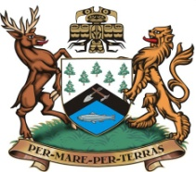
DISTRICT OF PORT HARDY
AGENDA

COMMITTEE-OF-THE-WHOLE COUNCIL MEETING
6:00 pm TUESDAY JANUARY 10, 2012

Council Chambers - Municipal Hall

A. CALL TO ORDER Time:

B. APPROVAL OF AGENDA

Motion required 1. 2.

C. PRESENTATION

1. Karsten Henrickson, Associate Regional Director, North Island College
Re: Update on North Island College / Mt. Waddington Regional Campus

2. Khris Singh, BC Rural Secretariat re: Update on the District of Port Hardy
Communities First Agreement.

D. ADJOURNMENT 1. Time:

