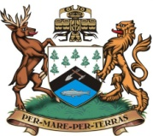
DISTRICT OF PORT HARDY
OPERATIONAL SERVICES DEPARTMENT
The District of Port Hardy is currently seeking energetic summer students interested in summer opportunities with our Operational Services Department. Our summer students will perform a diverse range of labor related duties such as grass cutting, raking, pruning, watering, painting, edging, and gardening tasks in District parks, trails, cemetery, sport field facilities and other municipal sites.
The terms and conditions of employment are in accordance with the IUOE Collective Agreement. Qualified individuals should forward their resumes, quoting “Summer Student” to Bruce Forsyth, Public Works Supervisor, at bforsyth@porthardy.ca or drop off at the Public Works Yard, 8900 Park Drive no later than 4:00pm, April 18, 2019.

We wish to thank all applicants for their interest and advise that only those to be interviewed will be contacted.
To be considered for this opportunity candidates must be either attending or returning to post-secondary institute at the conclusion of the summer season.

