

Scheduled Smoke Testing Notice

Smoke Testing will be occurring:

Wednesday, September 3rd, 2025 10:00am & 2:00pm

Areas affected will be:

Trustee Road and McDougal Road

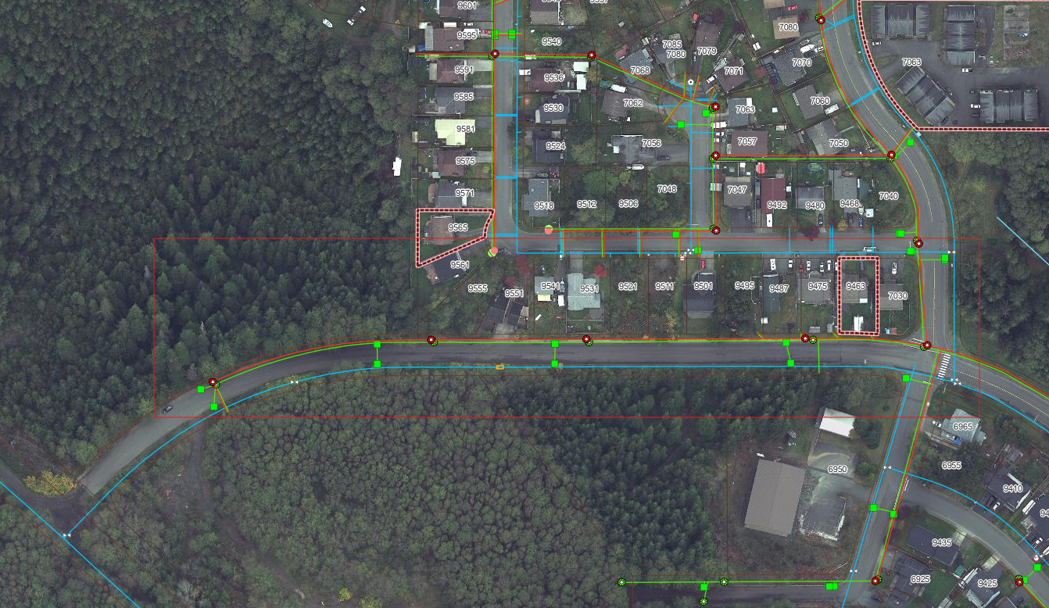

Thank you for your cooperation. Should you have any questions, please contact Operational Services at 250-949-7779.